Data and Accountability Committee Members – Bio

Lanzi Asturias
Specialist, Adult and Career Education
Los Angeles Unified School District
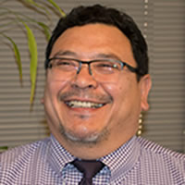
Lanzi Asturias has 21 years of experience in Adult Education instruction and administration. Since 2002, he has worked managing Specially Funded Programs and grants in collaboration with multiple Community Based Organizations, governmental offices, and private industry. Currently, Lanzi serves as the Project Manager of the Los Angeles Regional Adult Education Consortium leading the implementation and activities of the consortium’s Regional Comprehensive Plan. Under the direction of the Executive Board, he coordinates the efforts of Burbank, Culver City, Los Angeles and Montebello School Districts and the Los Angeles Community College District to align assessment and curriculum, accelerate student learning, provide comprehensive guidance, implement career pathways, and leverage resources for the benefit of all students in the Los Angeles Region. Lanzi holds a Bachelor of Arts and a Masters in Educational Leadership from The California State University, Los Angeles, and a Master in Business Administration from Pepperdine University.

Steve Curiel
Principal, Huntington Beach Adult School
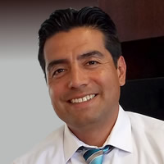
Steve Curiel has been involved in Adult Education administration for 16 years and has managed and lead each Adult Education program area at various times in his tenure. For the last seven years he has been the principal for Huntington Beach Adult School which serves over 7000 students annually. He has lead professional development activities for Adult Education administrators and staff on topics such as budgeting and accounting, strategic planning, and marketing. Steve is the President-Elect of the California Consortium on Adult Education, sits on the board of the California Consortium for Independent Study, and is the Orange County representative on the ACSA Adult Education Council. He has earned a BA in Social Sciences, a teaching credential in physical sciences, a K-12 administrative credential and an MBA.

Kelly Schelin
Dean, Economic and Workforce Development
Contra Costa College
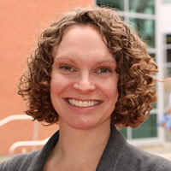
Kelly Schelin has over nine years of experience operating workforce development programs in the community college setting. As Dean of Workforce and Economic Development, Kelly works with faculty and employers to create and enhance training programs and pathways that address local workforce needs. In her former role as Director of Grants at Piedmont Community College in North Carolina, Kelly coordinated grant development efforts among educational partners, local businesses, and workforce development agencies to enhance the economic vitality of the region. Prior to serving in this capacity, she was the Associate Director of Workforce Development at Piedmont Community College, where she developed learning communities and integrated pathways designed to serve long-term unemployed and underemployed students.
Kelly holds a Master’s of Divinity from Duke University and a bachelor’s degree in Philosophy from Westmont College.

Karen Engel, Ph. D.
Interim Dean, Research, Planning & Institutional Effectiveness
College of Alameda
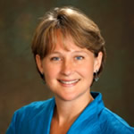
As Interim Dean of Research, Planning & Institutional Effectiveness, Dr. Engel is responsible for all of the research and planning for College functions, programs, services and activities through the continuous assessment and analysis of student needs.
Previously, as the Director of Economic & Workforce Development for the Peralta Community College District, Dr. Engel provided vision and leadership for the development and coordination of the District's career technical education (CTE) and workforce programs. She developed partnerships and linkages between the four Peralta Colleges and business and industry, coordinates programs with secondary schools and four-year colleges and universities, raised over $35 million in state, federal and private workforce development resources for the District and on behalf of the East Bay region.
Dr. Engel has over 20 years of experience leading regional economic and workforce development initiatives. She holds a B.A. in history and economics at Brown University and earned a master’s degree and Ph.D. in international relations and economics from the Fletcher School at Tufts University. She has been named one the Most Influential Women in Business in the Bay Area by the San Francisco Business Times.

