Dear Adult Education Student,
Great News! You may qualify to receive a $30/month credit on your Internet bill.
The Affordable Connectivity Program (ACP) benefit helps eligible families afford high-quality home Internet at a lower cost. It is funded through the Federal government, and we expect this benefit to last for the next 4-5 years.
If there is one thing that the COVID-19 pandemic taught us, it’s that having home Internet is essential. Having access to the Internet allows students to continue to learn, adults the option to pursue remote employment options, and all of us to learn new skills to remain competitive in today’s job market.
The Get Connected California! Coalition is a group of statewide organizations that believe that access to home Internet is fundamental to improving the lives of students and families. The Get Connected California! Coalition encourages you to follow the “Guide to Apply for ACP Checklist,” so that you can apply for ACP on your own.
However, if you feel you need someone to help you fill out the ACP application, we invite you to attend an in-person ACP Enrollment Site on Saturday, August 27th. Please visit www.internetforallnow.org/events to find out where an Enrollment Site is taking place in your community.
If you would like help with the ACP application over the phone, please call 866-675-6181 where you will be connected to a non-profit organization that can assist with your ACP questions and the application process.
Thank you,
<Adult School contact name>

The Affordable Connectivity Program (ACP)
Checklist
A Guide to Apply for ACP

Am I Eligible?
There are several ways you can qualify for the Affordable Connectivity Program (ACP).

Income: is at or below 200% of the Federal Poverty Guidelines.
Your household qualifies for the Affordable Connectivity Program (ACP) if it has an
income at or below the amounts listed below. This guideline is based on your household
size and state. You will have to show proof of income, like pay stubs or a tax return, when
you apply for the ACP Program (see chart below)

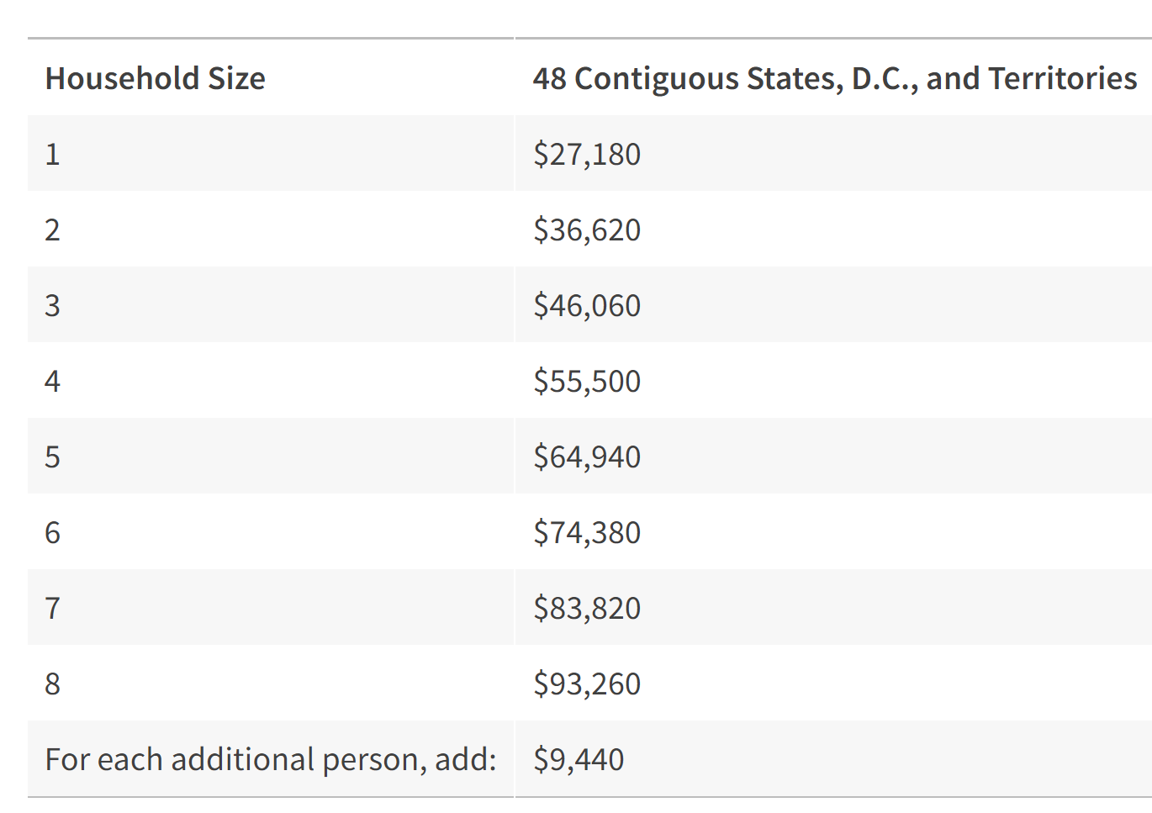

OR any member of the household participates in one of these eligibility programs:
- SNAP
- MediCal
- CalFresh
- WIC
- Supplemental Security Income (SSI)
- Federal Public Housing Assistance (FPHA)
- Veterans Pension and Survivors Benefit
- National School Lunch Program (NSLP)
- LifeLine
- Pell Grant

OR If You Already Receive a Lifeline Benefit
If you currently receive a Lifeline benefit, you automatically qualify for the ACP, and you can receive both benefits at the same time. You can apply your ACP benefit and your Lifeline benefit to the same or separate services. Talk to your internet company to learn how to start
receiving the ACP discount.
Checklist to Apply for ACP

What Do I Need to Apply?
Eligibility Document: You will need to show a card, letter, or document as proof that you participate in one of the qualifying eligibility programs when you apply for the ACP.

Identification for Yourself
One of the following:
Adult over the age of 18:
Social Security Number (not required)
Individual Taxpayer Identification Number (ITIN)
U.S. Driver's License
Other Government-issued ID, such as a state ID
U.S. Military ID
Passport (any country)
Identity documents must contain your first and last name and your date of birth.

You will need a current email address. This is where you will receive updates about your applications and any updates about the program.

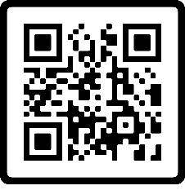
How Do I Apply?
Online: Scan QR Code for ACP Application
or visit www.internetforallnow.org/applytoday
OR

By Mail:
Print and fill out the ACP application
Print a copy of your identity documents (DO NOT send any original documents)
Send copy of your NSLP eligibility letter
Mail your completed application with proof of eligibility to:
Affordable Connectivity Program Support Center
P.O. Box 7081, London, KY 40742

Need Help with the ACP Application? No problem!
Call 866-675-6181 and a staff member from a local non-profit agency can assist you over the phone.
Attend an ACP Enrollment Assistance Site on Saturday, August 27th. Visit www.internetfoallnow.org/events or call 866-745-2805 to find locations near your community!

