Get FREE Home Internet with the Affordable Connectivity Program (ACP)

Location:
Time: xx am - xx pm

To sign up for ACP during the event, you must bring the following items:
I

Identity document (one of the following):
- U.S. Driver's License
- Government ID: State ID, U.S Military ID
- Passport (current from any country)
- Individual Taxpayer ID number
- Matricula or Visa Consular Card
- Birth Certificate (any country) for the minor that is the Benefit Qualifying Person (BQP)

Eligibility document (one of the following):
  - Monthly statement from Lifeline, MediCal, CalFresh, WIC
II
  - Proof of participation in National School Lunch Program NSLP) at CEP designated school
  - Pell Grant Award Letter
A valid email address (a representative will help you set up an email if you do not have one)

School Logo
Learn more at:

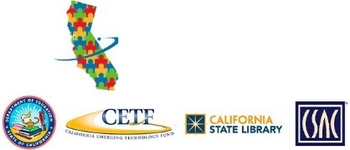
internetforallnow.org/events
GETCONNECTED
CALIFORNIA!
Call 866-745-2805

