Table of Contents
Overview: 2
Section 1: Consortium Details 3
Section 2: Assessment 4
Section 3: Metrics 6
Section 4: Objectives 12
Section 5: Activities & Outcomes 13
Section 6: Funds Evaluation 15

Overview:

The California Adult Education Program (CAEP) three-year planning process is designed to provide consortia and consortium members a chance to (1) collectively assess the impact of services provided over the previous period, (2) identify educational and workforce needs among adult education beneficiaries and providers in the region, and (3) define strategies and activities to meet these needs over the coming three years.

This document is the companion to the CAEP Three-Year Plan 2022-2025 Guidance. This template provides a high-level overview of the information to be included in each section of the three-year plan, as well as fillable text boxes that mirror the template in NOVA. CAEP consortia can use this document to outline the information that will be entered into NOVA. The official three-year plan will be completed and approved by all consortium members in NOVA. Certain sections in NOVA allow for adding additional tables and content; however, since this template is for outlining purposes only, there is only one table type included for each section.

Section 1: Consortium Details
In this section, information about the consortium, its primary and fiscal contacts, and CAEP funds received is auto populated in NOVA. Provide an Executive Summary (up to 5000 characters), briefly describing needs, three-year plan metrics, objectives, activities, and outcomes, and a summary of the funds evaluation. Additionally, at the end of this section, attest to several Assurances.

Consortium Name | Consortium Short Name
Address | Website
Funding Channel 2022-23 (Direct Funded or Fiscal Agent)
CAEP Funds 2022-23
CAEP Funds 2022-21
CAEP Funds 2021-20

Consortium Contacts
Primary Contact | Primary Contact | Primary Contact

Executive Summary (up to 5000 characters)

Section 2: Assessment
Gather data needed to describe existing adult education services, barriers, and needs. Evaluate both the needs for and the current levels and types of education and workforce services in the region, to identify gaps in current services.

Overview and Preparation (up to 5000 characters)
Provide a narrative description of the consortium’s overall Assessment approach, process, and data sources.

Regional Alignment and Priorities (up to 5000 characters)
Provide a description of the alignment of adult education and workforce services supported by CAEP with those described in other education and workforce plans guiding services in the region, including plans pertaining to the building of career pathways and the employment of workforce sector strategies and those required pursuant to WIOA.

Evaluate the Educational Needs of the Adults in the Region (up to 5000 characters)
Describe and evaluate the educational needs of adults in the region. To describe the educational needs, conduct a review of data on the region’s adult population. To evaluate the educational needs, critically review this data to determine its significance for the consortium’s adult education services.

Contributions by Entities (up to 2500 characters)
List all consortium members who contributed to the three-year plan process and briefly describe the ways in which each consortium member or partner contributed. Per California Education Code §84905(d)(1)(E), the consortium should have considered input provided by pupils, teachers employed by local educational agencies, community college faculty, principals, administrators, classified staff, and the local bargaining units of the school districts and community college districts.

Regional Service Providers
Enter the number of Participants in each applicable program area based on the available student data from LaunchBoard. NOVA provides the option to add additional non-CAEP-funded adult education providers by clicking on the “+Add Service Provider” button and entering the appropriate information.

Provider Name | Provider Type | #of Participants in Program Area
 |  | ABE | ASE | ESL | CTE | AWD | WR | PA | ACS
Total Participants
*Member Agency required to input number of Participants

Evaluate the Current Levels and Types of Education and Workforce Services for Adults in the Region (up to 2500 characters)
Conduct a review of data on the region’s education and workforce services, then critically review this data to determine whether it is sufficient to address the educational needs in the region, or where there are gaps in current services.

Section 3: Metrics

CAEP Barriers and Metrics
Each Consortium and their members, at a minimum, are required to complete targets at the consortium level (adults served & student barriers), and at the member level (Percent of Available Funds Spent, & Adults Served Who Become Participants). Student Barriers: Of the four student barriers listed (English Language Learner, Low Literacy, Low Income, Long Term Unemployed), select at least one from the drop-down menu.

Optional Metrics: Member agencies may choose from a list of ten optional metrics (see drop down menu). If a member chooses an optional metric, that metric will appear for all members in the consortium. If a member does not have students for a particular metric, they will enter 0 (if not planning to address) or set a target (if planning to address). If a member has students for a particular target but do not plan to grow their program, they will enter the same number as the actual.

Unfunded members will follow the same processes above as funded members.

Metrics | Notes on Metrics
Mandatory Metrics for Consortia
Number of Adults Served | - 1+ hrs. of instruction or received services
Barriers:  - ELL  - Low Literacy  - Low Income  - Long Term Unemployed | - ELL, Low Literacy, & Low Income are displayed on the Adult Education Pipeline dashboard as “If Ever Flagged,” as they are considered barriers that have long term impact and, in general, reflect a longitudinal change  - Long Term Unemployed is displayed on the Adult Education Pipeline dashboard as “Flagged in the Selected Year” as it is considered a barrier that can change quickly (i.e., employed)
Mandatory Metrics for Member Districts
Percent of Available Funds Spent
Adults Served Who Become Participants
Optional Metrics for Members
Participants Who Earn a High School Diploma or Equivalency
Participants with EFL Gains - ABE

Participants with EFL Gains - ASE

Participants with EFL Gains - ESL

Metrics | Notes on Metrics
Participants with Transition to Postsecondary (CTE) | - Limited to Participants in ESL, ABE, and/or ASE programs  - Transitions limited to transitions “for the first time” on the Adult Education Pipeline dashboard.  - Counts transition to a CTE program (either in a K12 adult school or community college) and entry into apprenticeship, pre-apprenticeship, job training, and/or a training program.
Participants Who Earn a Postsecondary Credential | - CASAS TE also captures outcomes beyond community college, such as earning a BA/BS or entering graduate studies, whereas COMIS is limited to community college awards listed in SP02 Student-Program-Award. In the Adult Education Pipeline, noncredit awards requiring fewer than 48 hours are excluded.
Participants with Transition to Postsecondary | - Limited to Participants in ESL, ABE, and/or ASE programs  - Transitions limited to transitions “for the first time” on the Adult Education Pipeline dashboard.  - Counts transition to any non-developmental, for-credit college coursework (includes but not limited to transfer-level courses).
Metrics | Notes on Metrics
Participants Who Became Employed in the 2nd Quarter After Exit | - The Adult Education Pipeline dashboard only uses the EDD UI Wage file match to populate employment and earnings metrics.  - Limitations: Data only shows for participants with SSN; excludes self-employment and enlistment in the military.  - Time lag: calculations are made in following academic year to verify that participant is not enrolled in any term/quarter first before flagging them as an “exiter” in the current academic year.  - Additional employment outcomes data can be found on TOPSPro via the Employment & Outcomes Survey.
Metrics | Notes on Metrics
Earnings Metrics: Median Change in Earnings | - Earnings metric has the same data limitations as listed above.  - Metric currently being displayed on the Adult Education Pipeline dashboard  - Metric captures the median change earnings across all exiting participants, as opposed to the number of exiting participants who experienced a wage gain.  - Median Change in Earnings is an effective way to show how learners have increased the dollar amount coming into homes.
Participants Who Complete an EL Civics COAAP or Course (Immigrant Integration Milestone) | - Immigrant Integration Indicators data from CASAS TE, which captures the EL Civics COAPP, is only available starting in the 2019-2020 academic year.

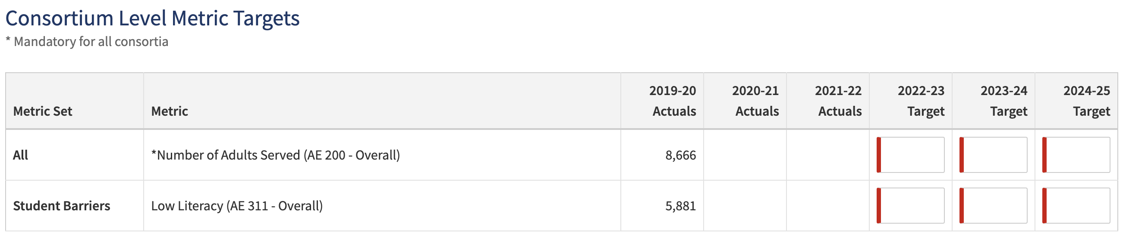

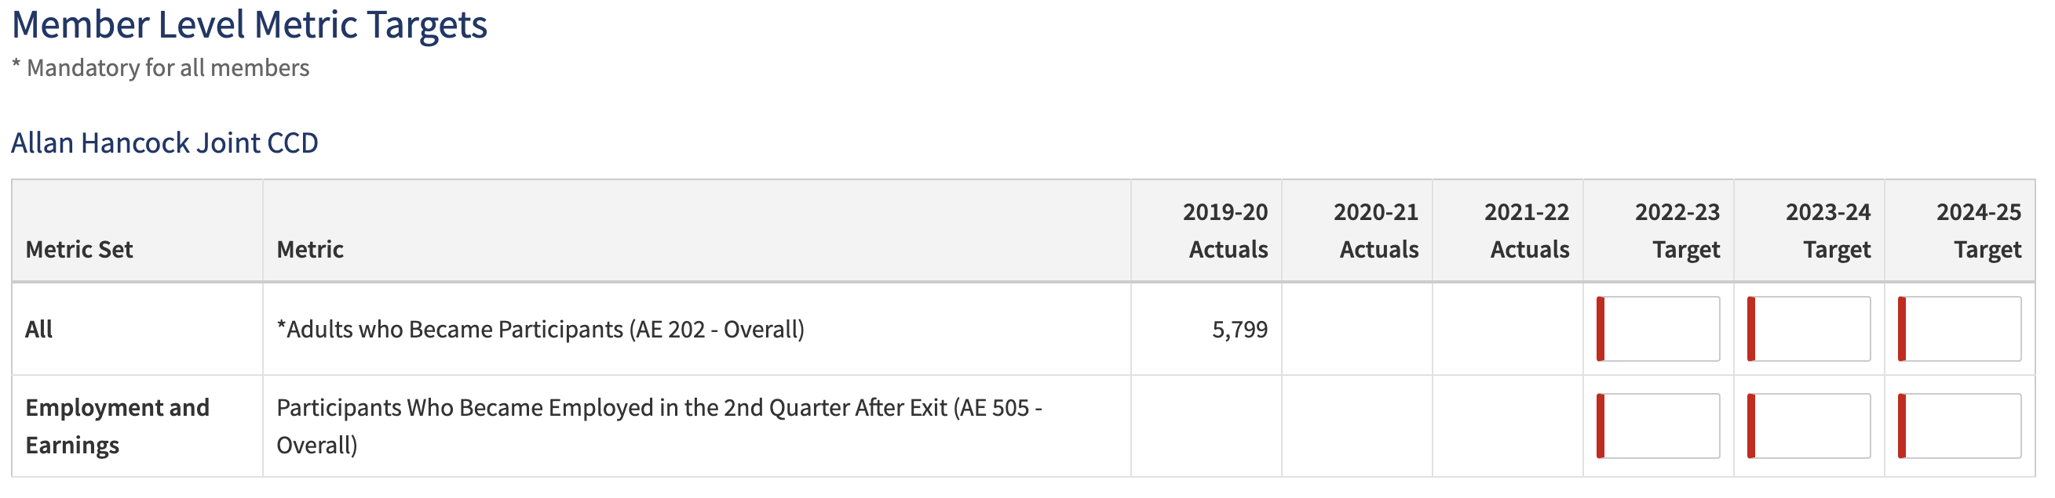

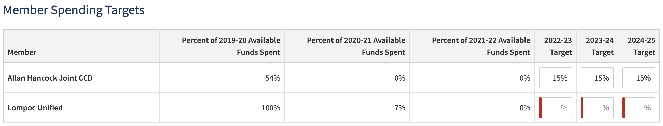

Section 4: Objectives
Describe strategies that the members of the consortium and others impacted by or interested in the provision of education and workforce services to adults in the region will take to (1) address educational needs, (2) improve integration of services and transitions, and (3) improve effectiveness of services.

Address Educational Needs (up to 2500 characters)
Describe strategies that the members of the consortium will use to address the educational needs.

Improve Integration of Services & Transitions (up to 2500 characters)
Describe strategies the members of the consortium will use to improve integration of services and to improve transitions into postsecondary education and the workforce.

Effectiveness of Services (up to 2500 characters)
Describe strategies the members of the consortium will use to improve the effectiveness of their services.

Section 5: Activities & Outcomes
Create a plan to implement the strategies named in Section 4 by defining activities and intended short-term, intermediate, and long-term outcomes. Activities may be proposed at the consortium or the individual district or agency level. Definition of long-term outcomes beyond three years is optional, as this is outside of the scope of the three-year plan but may be helpful for consortium planning.

Use the “+ New Activity” button at the bottom of the page to add each Activity proposed by the consortium to address the three Objectives in Section 4: Objectives. For each Activity, provide:
Activity Name | Objective that Applies to this Activity

Brief Description of Activity and Significance of Activity to Outcome (up to 5000 characters)
For each Activity, describe the activity, agencies or individuals that will carry out the activity, key deliverables, and how this activity contributes to a successful project outcome in the current period.

Short-Term Outcomes (12 Months) (up to 500 characters)

If accomplished, these activities will lead to the following outcomes in the next year.

Long-Term Outcomes (3-5 Year)
(up to 500 characters)

If accomplished, these activities will lead to the following outcomes in 3-5 years.

Intermediate Outcomes (1-3 Years) (up to 500 characters)

If accomplished, these activities will lead to the following outcomes in 1-3 years.

Adult Education Metrics and Student Barriers

Select from a drop-down menu one or more Adult Education Metrics and Student Barriers that align with the proposed activity. The drop-down menu will include all Adult Education Metrics and Student Barriers that were selected in Section 3: Metrics.

Responsible Position(s)
Name | Action

Proposed Completion Date for the Activity (any date within the three-year plan term)

Section 6: Funds Evaluation

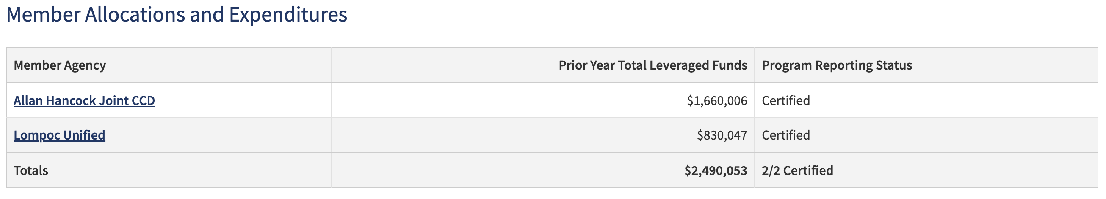

Funds Evaluation (up to 2500 characters)
Evaluate the funds reported for 19-20 by each consortium member as part of the Program Area Reporting exercise in NOVA. Critically review data on prior year leveraged funds to anticipate and assess how well the available funds will address the educational needs of adults in the region over the coming three years.

