Nine Ways to Promote Retention/Persistence

- Create Connections Among Students to Build Community & Create a Comfortable Learning Environment
- Help students learn and use each other’s names.
- Include ice breakers and some sort of class introduction during the first week
- Team projects for collaborative learning -- short, able to be completed in one class meeting.
- Small group conversation, discussion, brainstorming, presentations, online discussion boards with required responses to classmates.
- Give sincere praise in public; provide constructive criticism in private. Teach the “Growth Mindset” (e.g., mistakes are part of learning) and applaud efforts.

- Make Expectations for Attendance and Participation Clear
- Include attendance policy and class rules in syllabus and stress it all week long the first week, with reminders the entire term.
- Communicate expectations for active participation and punctuality.
- During the first week have students sign a contract and/or take a syllabus quiz.
- Create buy-in for cooperative, collaborative learning by explaining the reasons for pair and group work.

Example: Class Contract

Class Contract
I _____________________________ understand the following regarding my responsibilities as a member of the class at [school]:

- If I am absent, I will notify the instructor by phone call message, text, email, or via another student.
- I may be dropped from the class upon my fourth unexcused absence.
- I will be punctual by arriving on time for the class and returning from the break on time.
- I will attend every class. If I am absent for any reason, it is my responsibility to make up assignments, tests, class work, and homework.
- If I can no longer attend the class, I will notify the instructor so that another student on the waiting list can take my place and/or so that the instructor can officially drop me from the class.
- I will communicate in English and be cooperative with my classmates in pairs and small groups.
- I will use appropriate technology etiquette (cell phone, MP3 players, laptops, tablets, etc.). In the computer lab, I will do my classwork first and ask permission to use the internet for personal email, surfing, IMing, and Facebook) AFTER I finish all the assignments due for the day.

Signature ___________________________________ Date ______________________

- Help Students Set SMART Goals for the Class
- Help students set realistic, measurable goals for their time in your class and make a plan for achieving them
- Students should write down their goals and the steps they will take and revisit them periodically

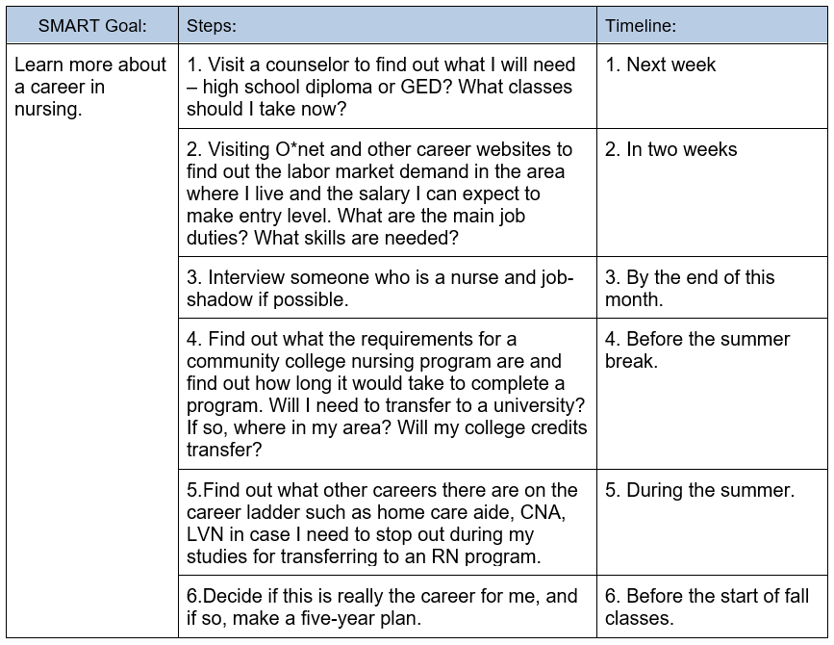

- Help Students Find Value
- Start each class with an objective for the day and an agenda.
- Regularly ask/tell students why they are learning/practicing something in class (relevancy to needs/goals) and how this learning applies to their needs, goals, lives. (Did you know this before today? It’s a good thing you came today – you learned something new!) Explain or show how newly-learned skills can be transferred to real-life situations
- Bring students’ experiences into the instruction – adults have many life experiences that they can contribute that with enrich the learning of everyone
- Use students’ names, experiences and problems/challenges (anonymously) in customized materials (handouts, quizzes, PowerPoint presentations, etc.)

- Scaffold Lessons with Review and Cycling of Content
- Include daily agendas with objectives/goals and activities.
- Review content from previous lesson to help students who were absent catch up.
- Connect content from previous lessons to new content.

- Give Students Choice and Autonomy
- Let students select one of two assignments
- Allow students to pick the topic of a reading or writing assignment
- Give students the option of doing extra work online
- Offer self-study packets or online exercises for those who have more time
- Post assignments and other materials on a class website for students to revisit
- Allow students to demonstrate learning in a variety of ways: an oral presentation, a written paper, a slideshow, a demonstration, a video
- Give students alternatives for approaches to the next topic on the syllabus
- Have volunteer students lead a lesson review

- Have Constant and Continuous Communication
- Send messages (texts, email) regularly: homework reminders, words of encouragement
- Call students when they begin to have irregular attendance

- Monitor Attendance and Performance – Teacher and Student
- Include regular, frequent low-stakes quizzes (weekly) for formative assessment and to promote study skills. Go over answers to clarify and review. Formative assessment can also be observation, games, Classroom Assessment Techniques (question on lesson content, attitude, or reaction to instruction), or student self-assessment checklists (“I can …” statements).
- Mark grades in a gradebook (online in a course management system like Moodle or Canvas) and have students check it regularly in class (computer lab).
- Have students mark attendance and assignment scores/grades on a Progress Tracker
- Give students opportunities to re-do quizzes
- Send emails or texts when students are absent and don’t let me know (“We missed you in class today. Please remember to call, text, or email me when you are absent. Here is what we did, so that you don’t get too far behind…”).
- Give students quarterly or mid-term only reports with message on what assignments are missing and what students need to work on, as well as what they are doing well.
- Instill pride and build students’ confidence by displaying their work (portfolios, e-portfolios, presentations)

Example: Student Progress Self-Tracker
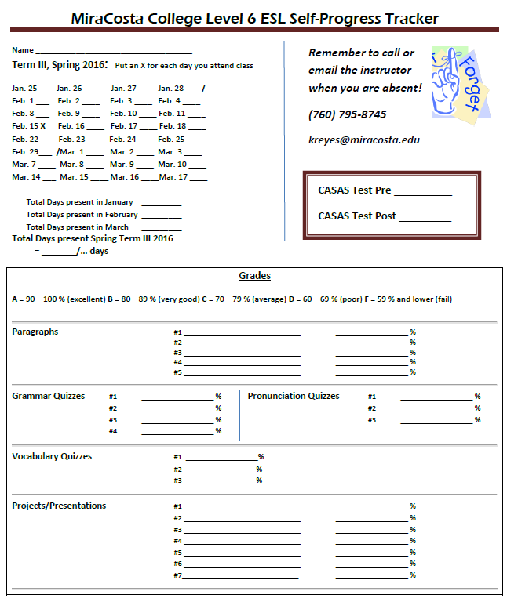

Example: Student self-assessment (EL Civics Education Unit)

Directions: Please answer the following questions about your learning and attainment of Student Learning Outcomes and lesson objectives in this class. Your input is appreciated and valued!

I can identify key information in a lecture or a conversation among speakers of English and other audio-video content and take notes.
- Yes
- Yes, but I need more practice
- No
I can interpret key information from authentic texts (articles, applications, Web sites) using a variety of reading strategies (for example, comprehend vocabulary words and phrases using context clues, make inferences, skim, scan).
- Yes
- Yes, but I need more practice
- No
I can compose a well-organized, coherent paragraph.
- Yes
- Yes, but I need more practice
- No
I can revise content, organization, grammar, and mechanics in my writing from feedback.
- Yes
- Yes, but I need more practice
- No
I can ask for information about college courses.
- Yes
- Yes, but I need more practice
- No
I can use a variety of language functional strategies (e.g. ask for and give clarification, ask relevant questions) by participating in formal and informal contexts.
- Yes
- Yes, but I need more practice
- No
I received feedback from my instructor that were helpful to my improvement of my English (writing and speaking).
- Yes
- No
Through analysis, I can determine similarities and differences between two education systems.
- Yes
- Yes, but I need more practice
- No
I can use a variety of study skills and strategies in order to accomplish educational goals.
- Yes
- Yes, but I need more practice
- No
I can use a credit college schedule to obtain class information.
- Yes
- Yes, but I need more practice
- No
I have a clear understanding of the areas of my listening, speaking, and reading, writing I need to improve.
- Yes
- No
Overall, how would you rate the instruction, preparation, and information you received about the process for transitioning to credit academic and/or vocational/career and technical education courses?
- Excellent
- Good
- So-so
- Poor

What has been the biggest improvement you have made in your English this term?
What was the most important thing you learned this term in this class?
What is the one thing you still want or need to learn or improve more?
Thank you for your feedback! Please enter any questions, comments, or suggestions.

Example: Mid-term Student Report

Level 7 Term II 2015 - Midterm Report for [Name Removed)
November 15, 2015, 6 p.m.

Total Online Hours = ____ 12
Item | Grade
Total | 84.27419%
Intro Presentation
Compare/Contrast Paragraph | 95.00%
Summary Paragraph | 100.00%
Pronunciation Quiz 1 | 90.00%
Prep Combos A Disc Brd | 4.00
Preposition Combinations A Quiz | 92.85714%
Prep Combos B Disc Brd | 0.00
Preposition Combinations B Quiz | -
Prep Combos C Disc Brd | 0.00
Preposition Combinations C Quiz | 93.75%
Grammar Quiz 1: Ger/Inf, Comp/Super, Qform, Advs/Agree | 68.57143%
Embedded Questions Test | 83.33333%
Extra Credit | 5.00

90 – 100% = A Excellent

80 – 89% = B Very Good

70 – 79% = C Work hard to catch up! Re-take quizzes with low scores and turn in missing assignments this week!

60 – 69% = D You have a lot of missing assignments. Perhaps you have been absent many days? Turn in missing assignments and do (or re-do for a better grade) the quizzes as soon as possible and see me if you have questions or need assistance.

Below 59% Time to get serious about your school work. Please don’t hesitate to see me if and when you don’t know what to do.

- Provide Opportunities for Reflection and Feedback (Both Students and Teacher)
- Use Classroom Assessment Techniques – periodically check in with students to find out what they understand /don’t, what they need more help with / practice in.
- Have students reflect on their learning (e.g., checklists or rating scales)
- Get mid-term feedback on course through an anonymous survey – what do they like/find useful, what not, what they want more of (teacher makes plan of action for remainder of term) and follow up by telling and showing students how you are using their feedback.
- Get end-of-term feedback on course through an anonymous survey – what went well, what can be improved (make an improvement plan for next term).
Example: End-of-Term Student Summative Evaluation by Teacher

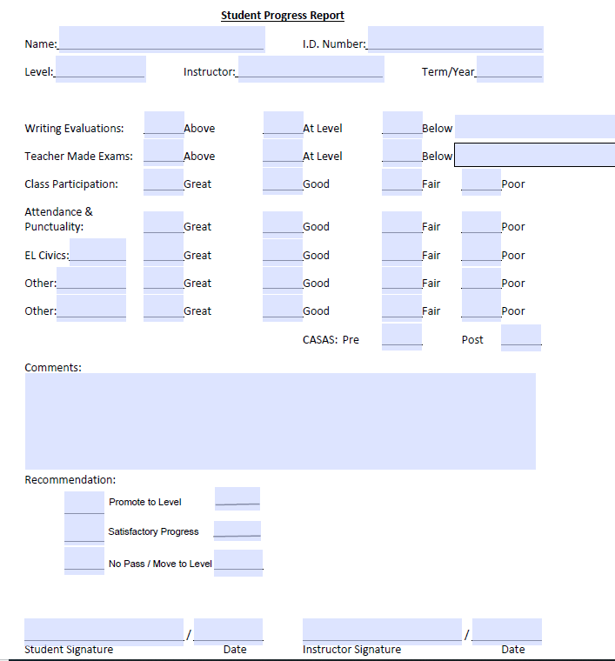

Example: End-of-Term Student Summative Evaluation for Teacher
Please evaluate the class. This is an anonymous survey. Your name will not be revealed with your evaluation and comments. Thank you in advance for helping me to grow and be a better teacher!
- What is something new you learned or something you improved this term?
- How could the class be better?
- In what ways could the instructor improve in her teaching?
- Would you recommend this class to other students? Explain why or why not
- Would you recommend this teacher to other students? Explain why or why not.
Thank you for taking this survey. Teaching is my passion, and I want to do my job the best I can. I appreciate any other comments or suggestions, so feel free to include them here:

