Providing Instruction Aligned to the
English Language Proficiency Standards
Part 1: Building Background Knowledge

Facilitated by Jayme Adelson-Goldstein
lightheartedlearning@gmail.com
OUR GOALS
By the end of our webinar, you should be prepared to
- explain the connection between the English Language Proficiency Standards (ELPS), the College and Career Readiness Standards (CCRS), and the 21st century needs of adult English language learners;
- easily navigate the ELPS document in order to make use of it when planning instruction;
- recognize the standards in action in different classroom settings; and
- launch into instructional planning tasks with the ELP Standards when we meet face-to-face.

Introducing your facilitator:
Jayme is a curriculum consultant and teacher educator who focuses on working with adult school and community college agencies across the United States to support instructors’ integration of rigorous and contextualized lessons aligned to the 21st century standards. She has developed online professional development courses and webinars for AIR, CALPRO (California), SABES (Massachusetts), and TESOL. In addition, her international workshops and speaking engagements have expanded her perspective while confirming the universal challenges and joys of our field!
Jayme Adelson-Goldstein
Lighthearted Learning
Throughout her more than 35 years as a teacher educator, Jayme’s focus continues to be on refining instruction that respects (and differentiates for) the needs of both learners and instructors.
Her recent publications include The Oxford Picture Dictionary 3e; Step Forward 2e: Standards Based Language Learning for Work and Academic Readiness; and the LINCS ESL Pro digital companion learning resource, Preparing English Learners for Work and Career Pathways.
***************************REFLECTION******************************
Before you begin viewing the Webinar, take a moment and reflect on your goals and needs around this topic. Consider the questions below:

Which of the goal statements on the cover is most meaningful for you?

What additional goals do you have for your time spent on the webinar?*

What will help you retain the content you hear and view during the webinar?

What do you hope to be able to do by end of the ELPS institute (by the close of our F2F session)?

Needs Assessment: What do you already know about the ELPS and the CCRS?
- View the webinar slides and circle the responses below.

- In what sequence did these two sets of standards arrive on the adult education scene in California?
  - A B
  - B A
- What do the CCR and ELP Standards prioritize, based on the shifts or advances in adult instruction?
  - Teaching and practicing complex grammatical constructions
  - Reading complex informational text with its academic language and citing evidence from the text
  - Interpreting and writing narrative text and poetry
  - Project-based learning
  - None of the above
- What do we mean by text?
  - Print text, graphs, and charts
  - Spoken text and videos
  - Images
  - A and B but not C
  - A, B, and C

- Which of the following is NOT a guiding principle of the ELPS?
  - Adult ELLs can meet state-adopted challenging standards.
  - Adult ELLs can acquire native-speaker pronunciation
  - Adult ELLs represent a diverse population
  - Social language plays an important role in English language acquisition
  - Adult ELLs’ funds of knowledge are a resource for their learning
- How many ELP Standards are there?
  - 40
  - 35
  - 25
  - 15
  - 10
- What is the relationship between the ELPS and the CCRS?
  - The ELP Standards replace the CCRS for ELLs
  - The CCRS is for advanced ELLs, and the ELPS is for beginning and intermediate ELLs
  - The ELP Standards provide the scaffolds that ELLs in ESL and ABE classes need to achieve the CCRS
  - They are the same, but one is written more simply
  - There is no relationship between the two sets of standards

The Evolution of 21st Century Adult Education Standards (SCAFFOLDED CORNELL NOTES)
Listen to the minilecture and take notes.
At the end of the lecture, complete the exit tickets. (You’ll be asked to bring this handout with you to the F2F session.)
Inquiry: What led to the development of the CCR and ELP Standards?
How do these standards reflect the needs of adult learners in the 21st century?
TOPICS  - Hallmarks of the 21st century  - Adult learners’ needs  - Instructional shifts that address these needs  - Integration of the shifts within the CCRS  - The connection between the ELPS and CCRS | DETAILS
EXIT TICKET 1:  Something I heard that  I have experienced first-hand: | EXIT TICKET 2:  Something I heard that  surprised me: | EXIT TICKET 3  Something I want to explore further:

Shift 1: Engaging with complex text and its academic language.
Look at four examples of complex text from (1) a paragraph out of a college textbook on reading, (2) a medical assistant’s textbook, (3) a janitorial training manual, and (4) a parent website portal’s announcement for a California school district. (See page 11 for sources.)
Choose one example and look for text features, sophisticated language structure, and/or vocabulary that would challenge your learners.
Think about how you would present this aspect of the text to your learners.
1

This lesson focuses on a method called Reading Apprenticeship. It is based on the premise that people who have become expert readers can assist learners by modeling what they have learned to do. As explained in the text, Reading for Understanding: How Reading Apprenticeship Improves Disciplinary Learning in Secondary and College Classrooms, “One literacy educator describes the idea of the cognitive apprenticeship in reading by comparing the process of learning to read with that of learning to ride a bike. In both cases, a more proficient other is present to support the beginner, engaging the beginner in the activity and calling attention to often overlooked or hidden strategies.”
This is a strategy that takes a metacognitive (how we think about how we think) approach to comprehension, utilizing various strategies readers may already know they know how to do, then adding even more. For example, most readers have learned to make predictions (think ahead to the next stage of a plot in a mystery, for example), ask questions concerning meanings (“I wonder about…”), visualize a scene being described, associate the material being read to some other material, and, at the end, summarize the material (particularly if required to do so by an instructor or for a paper).
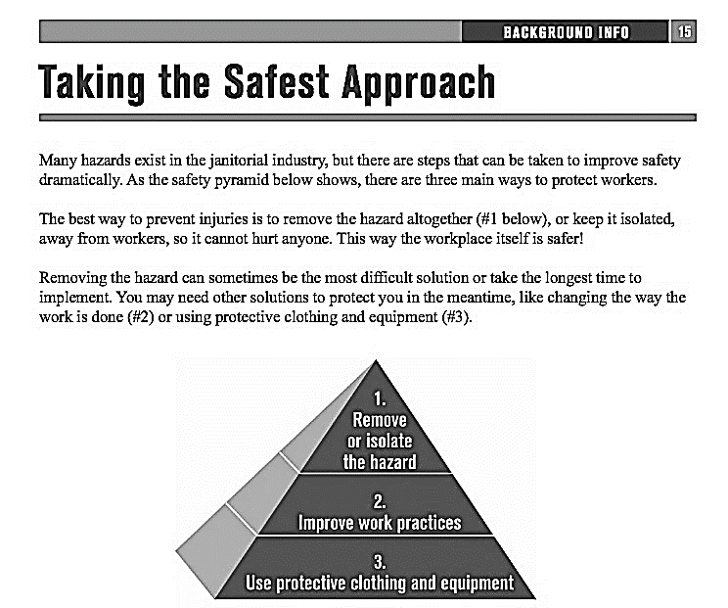
3
2
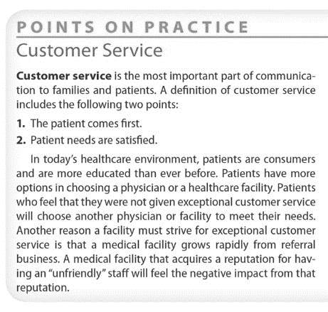

Please visit the Educational Equity Compliance Office to find out how the District ensures that all students are treated equitably in the District's programs and activities and provided an environment that is free from discrimination, harassment, intimidation, and/or bullying, including, but not limited to, all aspects of Section 504, Title VI, and Title IX compliance as well as Uniform Complaint Procedures and Williams/Valenzuela Complaints.

4

Shift 1: Engaging with complex text and its academic language.
The Academic Wordlist (AWL) is a list of words that appear with high frequency in English language academic texts across disciplines. The list was compiled by Averil Coxhead at the Victoria University of Wellington, New Zealand. The list contains 570 word families and is divided into 10 sublists, with sublist 1 words occurring with the highest frequency within texts. Most of the words on the list have multiple inflections and related words (word families)—for example, define, definable, defined, defines, defining, definition, definitions, redefine, redefined, redefines, redefining, undefined. Having access to these words is key to learners’ understanding of complex text.
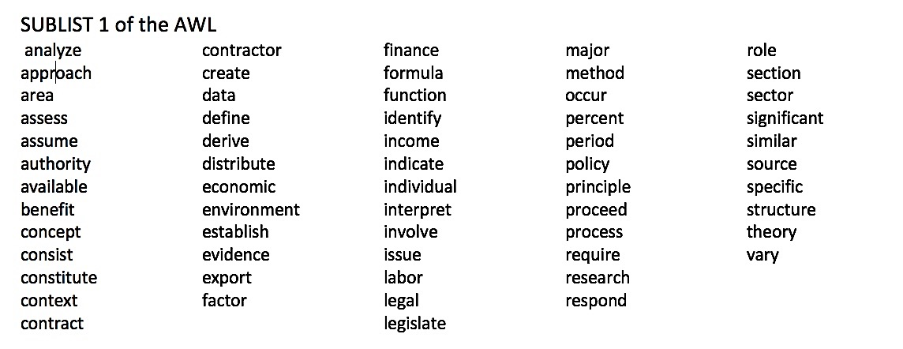
Look at the list of words on sublist 1 of the AWL.
How many words from this list do your learners know?
SUBLIST 1 of the AWL

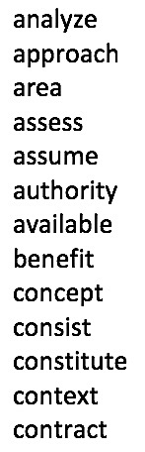
analyze
approach
area
assess
assume
authority
available
benefit
concept
consist
constitute
context
contract

Shift 2: Extracting and citing evidence from the text.
- Look at the news article summary and the six questions below.
Which questions are NOT text dependent? How do you know?

With consumers increasingly concerned about how their food is produced, interest in biodynamic farming is growing. While growing in popularity for wine production in Europe, Holistic Roasters also sees the potential for biodynamic farming in the coffee sector.

- According to the first sentence, what are consumers worried about?
- Have you ever eaten anything from a biodynamic farm?
- How important is the term biodynamic to this article? How do you know?
- Does the term Holistic Roasters refer to people or a company? Explain.
- How is coffee produced?
- Underline the phrase that tells you what is already being produced biodynamically.

Shift 3: Building knowledge from rich informational (nonfiction) text.
- Check the nonfiction topics below that your learners would be most interested in. Add others.
- space exploration  - UA history  - job search and interviews  - community activism  - future of technology  - happiness  - ___________________ | - diversity in the workplace  - cyberbullying  - success  - high-growth industries  - athletes’ biographies  - world leader biographies  - _______________________ | - cross-cultural issues  - parenting  - entertainer biographies  - movie reviews  - current events  - social media  - __________________
- Check the sources of texts you provide for your learners. Star any that you want to google and explore.
- Your core textbook’s readings
- Your core textbook’s listening passages
- A Reading Skills book’s texts (e.g., Read and Reflect, True Stories)
- A Listening Skills book’s passages (e.g., Listen First, Lecture Ready)
- Newspaper articles (e.g., LA Times, Chronicle, Sacramento Bee)
- Magazine articles (e.g., Time, Newsweek)
- Reading Rockets texts
- NEWSELA articles
- News For You articles
- Voice of America Special English News (listening passages and readings)
- Voice of America Stories about People
- Breaking News English (audio/text)
- TED Talks
- TED Education
- NPR broadcasts
- Podcasts
- YouTube videos
- Oxford Bookworms
- Awesome stories
- __________________________________

Navigating an ELPS Standard
- Annotate the standard using these labels:
anchor standard levels level descriptors
CCRS-ELA correspondence Math/Science/Engineering correspondence
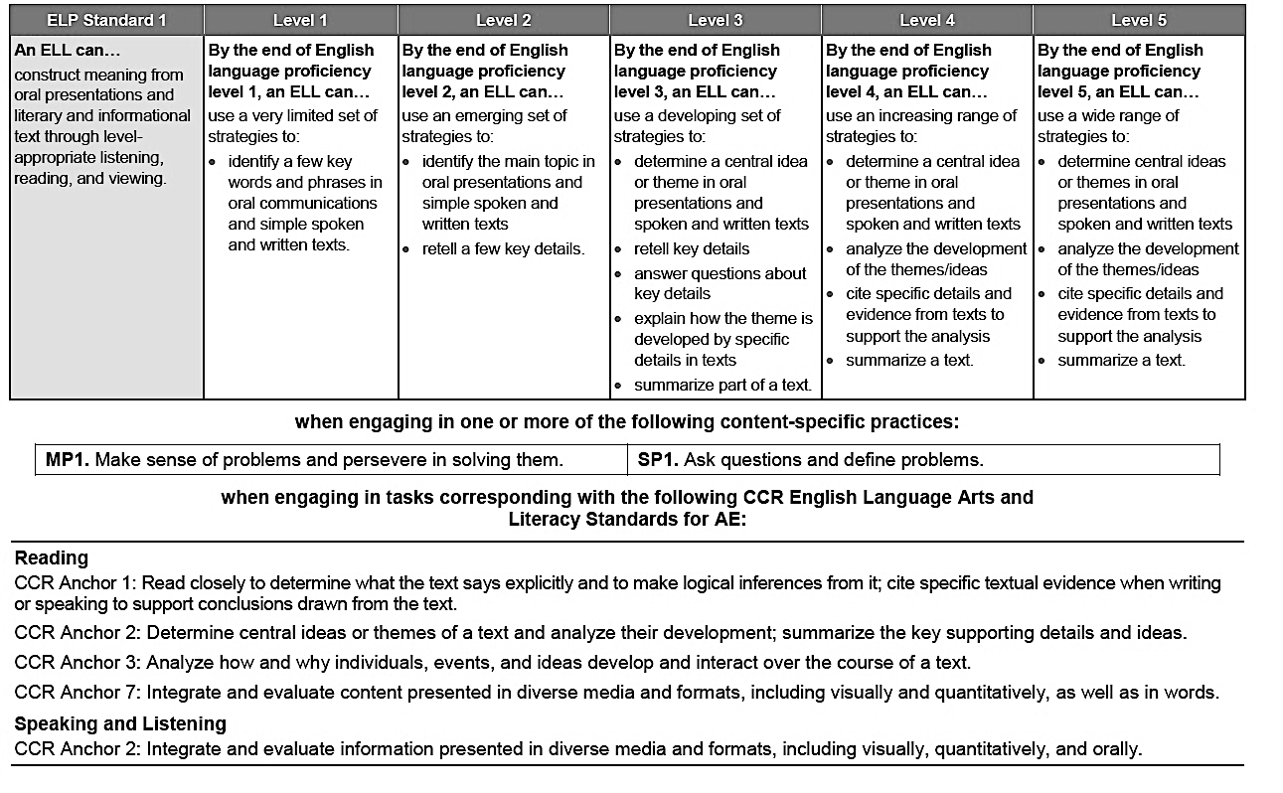

(Video) Classroom Observation 1
- Review the 10 ELP Standards on page 2 of the ELPS Extract.
- Watch video 1 and take notes on the lesson outline below.
- Review your notes and the standards. Did you see evidence of the learners working toward one or more standards? Write the number of the standard near the evidence in the lesson outline.
LESSON TOPIC Voting Rights Level: High Intermediate/Advanced
LESSON OUTLINE:
STAGE | What did you see? | Evidence of work toward standard(s)?
Warm-Up/ Introduction
Present
Practice
Present
Practice
Application
Evaluation
See the complete lesson at https://www.youtube.com/watch?v=Hrol_D_ujsc&feature=youtu.be

(Video) Classroom Observation 2
- Review the 10 ELP Standards on p. 2 of the ELPS Extract.
- Watch the video 2 and take notes using the lesson outline below.
- Review your notes and the standards. Did you see evidence of the learners working toward one or more standards? Write the number of the standard near the evidence in the lesson outline.
LESSON TOPIC: Employment LEVEL: Pre-Beginning
LESSON OUTLINE:
STAGE | What did you see? | Evidence of work toward standard(s)?
Presentation 1
(Vocabulary)
Guided
Practice
Communicative Practice
Presentation 2
Text features
Guided Practice
Key Details
Presentation 3
Reading the Text

Guided Practice
Reading the Text
Formative
Asssessment
See the complete lesson at https://www.youtube.com/watch?v=onX5rpQvIvg&feature=youtu.be

Assess your comprehension of the webinar content.
- Review your answers on page 2 and check them against the recording.
- Consider your readiness to dive more deeply into the ELPS.
- Use the key below and our Webinar goals
1 = extremely confident I can do this 2 = confident I can do this
3 = fairly sure I can do this 4 = not ready to do this, need more support
- I can explain the connection between the ELPS, the CCRS, and the 21st century needs of adult English language learners.
- I can easily navigate the ELPS document in order to make use of it when planning instruction.
- I can recognize the standards in action in different classroom settings.
- I am ready to launch into instructional planning tasks with the ELP Standards when we meet face-to-face.
Next Steps
Between now and our face-to-face session:
- Review your notes on page 3.
- Print out the ELPS Extract and review the 10 standards before our workshop.
Bring the following to our face-to-face session:
Your exit tickets from the notes on page 3
Your ELPS extract
A smartphone, tablet, or laptop
A lesson plan you have recently taught (or will teach)
OPTIONAL: your textbook
References

ACT, Inc. (2006) Reading Between the Lines: What the ACT Reveals about College Readiness in Reading. Iowa City, IA: Author

Booth, K., Whicker, L. and Wyman, T. (2013) Medical Assisting: Administrative and Clinical Procedures with Anatomy and Physiology, 5th Edition. p. 45 New York, NY: McGraw Hill.
Commission on Health and Safety and Workers’ Compensation, Labor Occupational Health Program, & UCLA Labor Occupational Safety and Health Program. (2009). Janitorial safety training guide. Berkeley, CA: University of California, Berkeley.
Los Angeles Unified School District. (n.d.). Educational Equity Compliance Office. Los Angeles, CA: Author. Retrieved from https://achieve.lausd.net/Page/3494
Nissila, P. (n.d.). How to learn like a pro! Lesson 3.1: Comprehending college level reading by using the Reading Apprenticeship approach. Salem, OR: Open Oregon Educational Resources. Retrieved from https://openoregon.pressbooks.pub/collegereading/chapter/lesson-3-1-comprehending-college-level-reading/
U.S. Department of Education, Office of Vocational and Adult Education. (2013) College and Career Readiness Standards for Adult Education. Washington, D.C. retrieved from
http://lincs.ed.gov/publications/pdf/CCRStandardsAdultEd.pdf

U.S. Department of Education, Office of Career, Technical and Adult Education (2016). English Language Proficiency Standards for Adult Education. Washington, D.C.: American Institutes for Research. https://lincs.ed.gov/publications/pdf/elp-standards-adult-ed.pdf

Image credits

Slides 1 ,3, 16, 19, 20, 24, 48 Deposit photos (Standard license)
Slide 2 - LINCS ESL PRO Companion Learning Resource (AIR) p. 4
Slides 14, 16, 17, 18, 19, 20, 25, 26, 31, 32, 35, 39, 58 – Pixabay.com (CC license)
Slides 42-48, 61 -ATLAS-Minnesota Literacy Council. (2018) CCRS in ABE Video 1- Intermediate ESL
retrieved from https://www.youtube.com/watch?v=Hrol_D_ujsc&feature=youtu.be (CC license)
Slides 51-55, 61- ATLAS-Minnesota Literacy Council. (2018) CCRS in ABE Video 2- Pre-Beginning ESL
retrieved from https://www.youtube.com/watch?v=onX5rpQvIvg&feature=youtu.be (CC license)
Slide 59 - Illustration by Gary Goldstein (CC license)
Slides 62- AIR-AEP photo from 2018 Rigor training
Slide 63- laptop, tablet, cell phone—Pixabay.com (CC License); textbooks- JAG photo
Slide 64- selfie photo by JAG

